***An Anthology of***

***Problems in Mathematics***

***Dr. Roy Lisker***

***50 Problems at the graduate level***

***in Geometry, Algebra,Analysis***

***Linear Algebra, Logic. Dynamical Systems, Physics,and Number Theory***

***Part 1***

***Problems 1-27***

***Roy Lisker***

***Ferment Press***

***8 Liberty Street#306***

***Middletown, CT 06457***

*GEOMETRY*

Problem 1

Convex sectors

Fix points A and B in the plane. For simplicity they may be placed on the x-axis of a Cartesian reference frame . Connect them by *two convex arcs* in the upper right-hand (+,+) quadrant , C1 and C2 . (Figure 1)

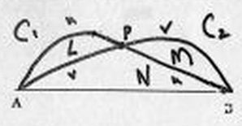

Figure 1

Assume that C1 and C2 intersect *only* in their *mutual mid-point* , p . This divides C1 into arcs of equal lengths u , and C2 into arcs of equal length v .

Let     be the two sectors formed between C1 and C2 on the left, and C2 and C1 on the right.

To Prove: Area  = Area   .





Double Intersection

Projective Geometry

**Consider the family C of curves in polar coordinates:**



Problem 2:

**(i) Show that two curves S1, S2 with different values of D but identical values of , are parallel, i.e. non-intersecting.**

**(ii) Show that two curves with differing values of  always intersect in exactly two distinct points.**

**(iii)Show that through two points on the plane that do not rest on the same line emanating from the origin, there pass exactly two curves from the family C**

**(iv)Analyse the properties of C in relationship to the related family C* given by:**







Problem 3:

A Generalized Pascal Theorem

Let L be any smooth, closed, convex loop with clockwise orientation in the Euclidean or Projective Plane. ( Note that "convexity" is a projectively well defined concept by the Axioms of Projective Geometry.)The smoothness need only be C1 . That is to say, there must be an unambiguous tangent at every point.

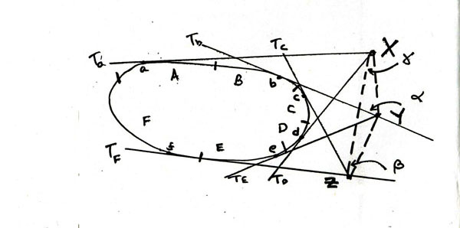

Subdivide the arc of L into 6 half open segments, going clockwise, with the terminal point at the beginning of each segment, as shown in the above diagram . Label these segments A, B, C, D, E and F.

*Theorem:*

One can always find 6 points

pA  A , pB  B , pC  C , pD  D , pE  E, pF   F, such that the intersections:

X of tangents drawn at pA and pD ;

Y of tangents drawn at pB and pE ;

Z of tangents drawn at pC and pF

are collinear.

Algebra

Algebraic Integers on the Unit Circle

Problem 4:

Let P(z) be an *irreducible* polynomial of degree n :

. Suppose that:

(1) a0 = 1 .

(2) One of its roots (and its complex conjugate) is on the unit circle,

*Prove :*

For n = 1,2,3,4,5 , P(z) is a cyclotomic equation that is to say, all of its roots are roots of unity.

Problem 5:

Show that this property fails dramatically for n = 6.





**Problem 6:**

Combinatorics of Semigroups

Let  be a set of 3 elements under the action of any arbitrary binary groupoid operation:

,

eij being the table entry for the product of ei and ej . The table  thus contains 9 entries.

*Define:* k1 = number of instances of e1 in T ;

k2 = number of instances of e2 in T ;

k3 = number of instances of e3 in T

Prove :

(i) If  , then (E ,) cannot be a semigroup .





Problem 7:

Will any other partition of 9 = k1+ k2 + k3 produce tables T, none of which are semigroups?





*Antigroups*

In the discussion that follows G is a finite group, A an antigroup.

An *antigroup*  is a subset A of a group G such that no product xy of elements x and y in A is an element of A :

*Definition:*  A is an antigroup if 

A *maximal* antigroup S is an antigroup such that if g is any element of G not in S, then the union of S and g,  will not be an antigroup.

The product set A2 = AxA will be designated T

The set of inverses of elements of A will be designated R.

The set of elements q of G such that q2 is an element of A will be designated V.

Problem 8:

Given S maximal , show that . Hence for S maximal, 

Problem 9, *Decomposition Theorem:*

Given S maximal , show that 

We will say that A is a particular form of an antigroup designated as a  *triduct*  ( triple product set) if 

Problem 10:

Show that when A is a triduct :

(a) 

(b) A2 is a group

(c)  is a group

(d) Show, in fact, that A2 is a normal subgroup of B, A is a coset of A2 , and that A contains an element k, with A = kA2 , and

k2 = e , the identity.

Problem 11:

Let Zk be the additive group modulo k

(i) List all integers k such that Zk contains one or more maximal antigroups of a single element.

(ii) List all integers k such that Zk has maximal antigroups of two elements.

(iii) Find an integer j such that

(a) Zj contains a maximal antigroup S of 2 elements.

(b) In the decomposition  , V is non-vacuous. Show that there is only one such j .





Analysis

Problem 12:

A Topology on Permutation Space

Let Z+ = the positive integers = (1,2,3,....) , and let S be the space of all automorphisms of Z+ . The elements of S  can be interpreted as permutations. For example, the permutation that switches adjacent pairs 2n+1 and 2n can be notated  = (21436587.....) , indicating both a sequence and a set of operations: " *Move the first entry to the second place and the second entry to the first; move the fourth entry to the third place and the third entry to the fourth*  ", etc.

S is a group. Let   and  be two such permutations:

= (s1 , s2 , s3 , ..... )

  = ( r1 , r2 , r3 .... )

Multiplication in S  is defined as :

.

*“The elements of  are the numbers of  indexed by the numbers in * . “

The identity for this group is e = (123456789....)

"*Leave everything where it is.* "

We will now place a topology on S via a map into infinite dimensional real Hilbert Space:



(A) Define the norm of a vector u in H , as is normally done, as the square root of the sum of the squares of the components:



Problem 13:

Show that Norm  = 1 for all   in S. The image of S in H will therefore be a subregion of the unit sphere S∞ of H .

(B) We can pull back the inner product <u,v> on H onto S to produce a functional  , from S to the positive real numbers .

Definition: If   S , then  is given by



Problem 14:

(i) Show that, for any two permutations  and  



Define the *distance* D , between two permutations as



Show that:

(ii) D(e, ) <1 for every permutation  .

(iii) 

(iv) Given real numbers 0 <  < 1 , and  arbitrarily small, there exists a permutation   , such that :



Problem 15:

A Curious Infinite Product

Let x > 1

(i) Show that 

(ii) Show furthermore that 

(iii) Generalize .

Problem 16:

Self-Inverting Analytic Functions

Let (z) , not identically zero, be an analytic function over the complex plane, subject only to the condition that all its derivatives be uniformly bounded:



Show that there exists another analytic function (z ) , with (0) = -1 , such that the function:  is self-inverting. That is :

(a)  (0) = 0

(b)  ( (z))= z in some neighborhood of the origin.

Problem 17:

An exotic differential equation

Designate by E the differential expression:



(i) Determine the auxiliary solutions, E = 1.

(ii) Show that , away from z=0 , E =0 has derivatives of all orders.

(iii) At any k different from 0, use the Maclaurin series to determine a solution of E =0 around k. Give the explicit form when k= 1

(iv) Setting z=0 in E, one sees that if there is a solution at 0, then f(0)=1. Is there an analytic solution at z=0 ? Give a formula for its derivatives there. What is its radius of convergence?

(v) Why is the form of f at k = 0 so different from that for k away from 0 ?

Dynamical Systems

*A Linear Chaos Machine*

This dynamical system has the advantage over such things as the logistic function , or the function that generates the Mandelbrot Set , that all of its parts are linear. In particular since there are no polynomials of degree >1, everything is real variable. The Chaos Machine operates inside the real domain 0 < x < 1 , and has been carefully constructed so that fixed points, periodic cycles, inversion properties, etc., stand out clearly.

The Linear Chaos Machine M has two branches.

*Define:*



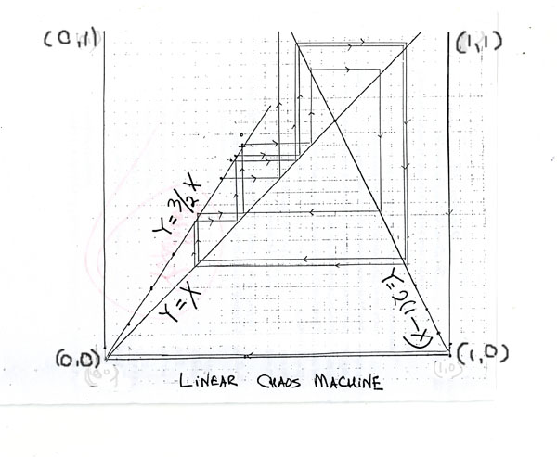

The graph of M appears above. The line y=x is included to help in the analysis of its iterative properties:

*Notation :*



An n-cycle is a sequence of *distinct* iterates such that x(n) = x:



An n-cycle is not the same as a periodic sequence of period n because of the requirement that all the iterates be distinct.

Label the half-open interval [0, 1/2) as L, the closed interval [1/2, 1] as R.

Problem 18:

(i) 0 is obviously a fixed point of M . Locate the other fixed points.

(ii) Show that there are no 2-cycles in M .

(iii) Find all 3-cycles; all 4-cycles

(iv) Show that, for every n, the number of n-cycles is finite.

Problem 19:

*Iteration of subsections*

For this following problem it will be helpful to consult and even mark up the graph:

(i) Find F>0 in L such that . Show that F is unique.

(ii) Find  in L such that . Show that  is unique.

(iii) Locate points s1 , s2 in L such that . Show that they are the only solutions in L . Label the larger value I.

(iv) Label the non-zero fixed point as C . There is a unique number G such that G is different from C ,  . Find G.

(v) Show that:



(vi) Show that :



Problem 20:

*Symbolic Dynamics*

Consider sequences of the form

S = A0A1.....Ak-1 , where

(i) A0 = L ;

(ii) Aj = L (left) or R (right) . 1< j < k-1 .

S will be called an *iterative sequence*  , or an *iterative k-sequence* . Such sequences are central to the subject of symbolic dynamics.

The formula Ik (x) = S = (x)A0A1.....Ak-1 will mean



S will be called an iterative sequence for x . A number x satisfying

Ik (x) =S will be called a solution of S, and the set of all solutions of S will be called the solution set, Q, of S .

Show that Q is empty if there are any 'isolated R's' in the sequence, that is to say, sections of S of the form ...LRL ....

Problem 21:

If S has no isolated R's, we will say that S is *proper* . If , then the set of iterations of x form a k cycle.

(i) Show that S cannot be the sequence corresponding to a k- cycle if it terminates with Ak-2 = L , Ak-1 = R . A sequence in proper form with this added condition is said to be *strictly proper* .

(ii) If S is a given sequence of the above form and Q is its solution set, show that Q *contains at most one k-cycle x*  for which S is the corresponding iterative sequence.

Problem 22:

*Fundamental Theorem (Difficult)*

Let S =S = A0.....Ak-1 be a strictly proper iterative k-sequence.

( For this theorem it is not required that A0 = L ).

Let  be any real number 0 <  < 3/4

*Prove:* There exists a number  , 0 <  < 1, such that



An Unusual Attractor

Problem 23:

**Let Q be the set of all non-negative rational numbers. Define a function on Q as follows: if r is an element of Q, write it as r= p/q, where (p, q) =1, that is to say in lowest terms. Then the numerator function P is given by P(r) = p. Define a function   **



**Let  (n) (r) be the nth iterate of j. Show that:**







**Linear Algebra**

Problem 24:

Factoring Polynomials Over Matrix Rings

We are interested in the decomposition of quadratic expressions of the form



over the ring M2 of all 2x2 matrices with real or complex entries, as a product of factors linear in the variables and with coefficients in M2 .

In what follows, constants and variables taking real and complex values are identified with their value times the identity matrix. Thus

, etc.

The decomposition will then be of the form :



, where       , are 2x2 matrices.

(i) What conditions on the coefficient a, b and c permit a factorization in which some or all of the matrices are non -singular? What are the corresponding matrices?

(ii) When these conditions are not present        will all be singular. What is the general solution?

(iii) Without going into the details, can you propose a method for factoring the general quadratic

 over M2 ?

Matrix Operators

Let A be an nxn matrix. A can be written either in terms of its rows as



or in terms of its columns as: , where

R1 = (a11 a12 a13 .... a1n ) , C1 = (a11 a21 a31 .... an1 ), ... etc.

"Row operations" on matrixes are those permutations which switch rows with other rows, or columns with other columns. We introduce a new set of operators, "switching operators" k , which switch the contents of row k with those of column k according to the scheme :

.

Unlike the row operations these operators cannot be represented by matrices or matrix multiplication, but belong to a operator algebra isomorphic to the symmetric group on n2 objects .

For example, a typical 3x3 matrix can be represented as

.

Application of the operator 2 changes this to:



Problem 25:

Show that , for n > 2 , no combination of row operations and switching operators can interchanges a11 with a12 , all other entries being left unchanged.

*Problem 26:*

Given the nxn matrix A, let P(A) represent the operator that switches entries a11 and a12 , leaving all others unchanged.

(a) Verify that the transpose operator, PT(A) = (P(AT)) T

will switch a11 with a21 , leaving all other entries unchanged.

(b) Show that :

(i) 

(ii) 

(iii) Does this imply that  ?

(iv) Describe the elements of the group  of operators

I, P, PT , etc.

Problem 27:

Give an informal argument to show that, by combining row operations and the operators P and PT , it is possible to switch any two entries alm , ars in A, leaving all others unchanged. Thus, row operations and the group  together generate the full symmetric group,  .

