**************************************
Circular Tangram Pieces in a 4-inchx2√3 inch block

1.Plain Set

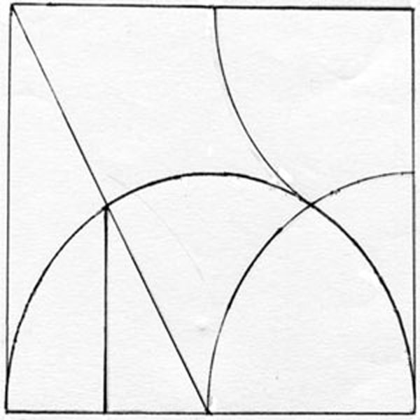

**************************************

2. Textured Set

**************************************

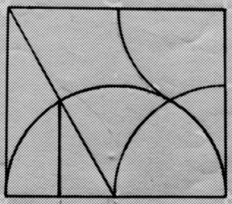
**************************************

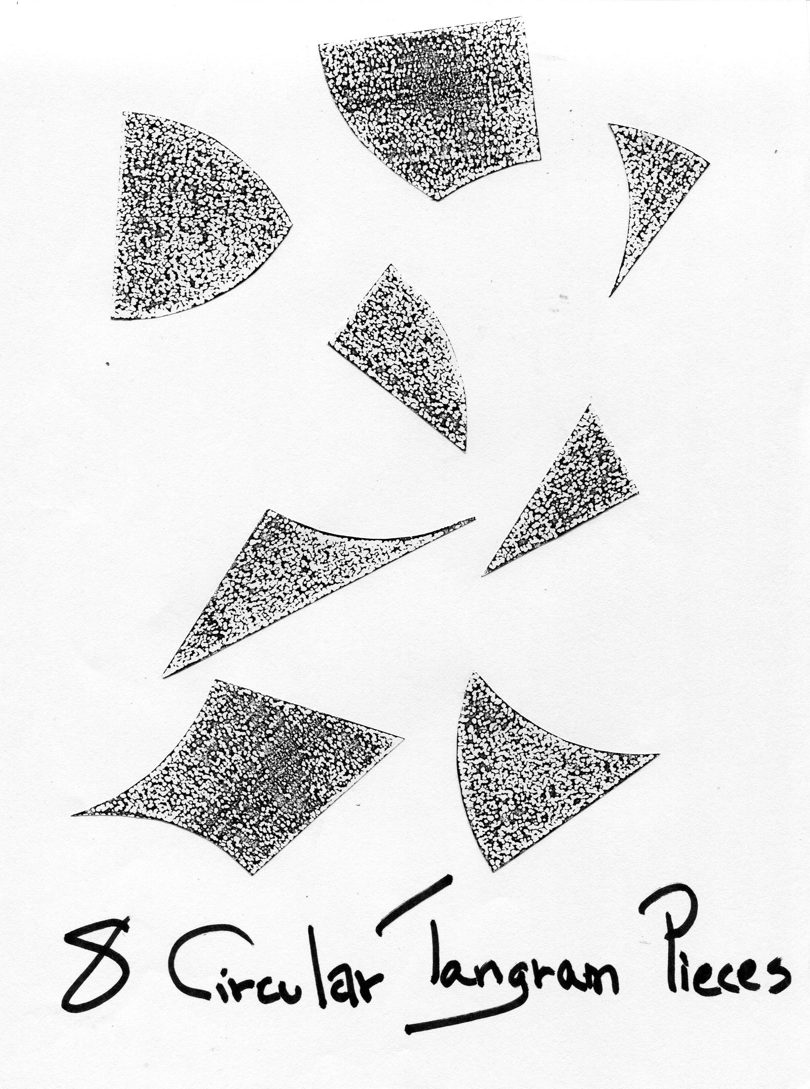

3. Blueprint for designing your own set
**************************************

