Relativity on 2-Manifolds
Dr. Roy Lisker

rlisker@yahoo.com
www.fermentmagazine.org

Relativity, Galilean, Special and General
The existence of a dynamics based on Galilean Relativity, on a connected two manifold M requires three principles.
We assume a connection on M , from which it is possible to define a metric, curvature and geodesics in the usual fashion.
Principle 1
- (Local (relaxed)Uniformity): M is everywhere
"locally self-isometric": Given any two points x and y on M , there exist neighborhoods , N_{x} Ny , and a diffeomorphism ϕ on M,
such that the metric imposed on M maps Nx isometrically onto Ny. We call such surfaces uniform. Note that the isometry does not extend to all of M.
Simply stated, P₁ implies a constant curvature at every point
of M. The converse is not true: for example, a surface formed by the
perpendicular intersection of two planes in 3-space will have zero
curvature everywhere, but neighborhoods of points along the
intersection line will not be homeomorphic to neighborhoods of
points away from the line.
- (Strong Uniformity) : M is everywhere self-isometric . Given x
and y, there is a congruence isometry mapping M into itself and x into y.
The cone surface
satisfies the relaxed principle but not the strong principle: the cone is “self-similar” , not “self-isometric”. However, given two points on the cone, there are patches around each point that are isometric and congruent.
The sphere is obviously strongly uniform . The Torus in 3-space satisfies neither version of P_{1,} having its minimum curvature on the outer edge and a different maximum curvature on the inner edge. Sphere, Cylinder, Flat Torus, Plane, and Hyperbolic Plane are strongly uniform. Such surfaces have no distinguished points.
On uniform surfaces it is possible to use the Principle of Least Action to define uniform motion and constant velocities. All geodesics on such surfaces will themselves be locally or globally self-isometric 1-manifolds at every point.
Examples: Let C be a cone. If the central angle of C is less than π/2, the natural geodesics on the cone surface geodesics cannot be
globally self-isometric since they will have self-intersection points.
However these geodesics are locally self-isometric on segments which do not extend to their self-intersection loci. Whether locally
or globally, it is possible to define uniform motion, inertial motion
and inertial frames along geodesics, as those that covers equal
distances in equal times.
Definition: The motion of an object at a constant speed, along a geodesic (measured by arc length) will be called an inertial motion .
Uniform curves which are not geodesics exist of course , and it is possible to define uniform motions along them. We do not call these inertial motions. The circles other than great circles on a sphere are uniform curves, but they are not the paths of least action and hence motion along them is not “inertial” . Although the torus is not a uniform surface in our terms, the rings normal and parallel to the plane of the torus are both uniform curves and geodesics, and one can speak of inertial motion along these curves.
Since we will not be discussing collisions in this paper, masses and momenta can be ignored.
Principle 2 : A mass moving along a geodesic in uniform motion cannot detect its own motion. Obviously one can endlessly debate what is meant by saying that's one "motion" cannot be "detected". Perhaps one ought to put Principle 2 into the form of a definition:
Definition: An undetectable motion will be defined as the motion of an observer along a geodesic at a constant velocity (as measured by its arc-length).
Such a definition makes “undetectability” contingent on the choice of a metric, and should put to rest the anxieties of the 17th century Inquisition as to whether the earth “really moves”!
The problem still remains, how does one detect a detectible motion? Here mathematics has to yield to physics:
Definition: We will say that one's motion has been detected by virtue of the following kinds of evidence:
(1) There is increase, decrease or dissipation of energy, generally in the form of heat, and attributable to no other cause.
(2) There are changes in the local geometry, notably the
curvature. For example, one could detect changes in local curvature
by drawing a triangle in one's immediate neighborhood and
measuring the sum of its angles. One might also argue that the space is changing while the object remains “in one place”. This is an abuse of language. “Motion” by definition is the change, through time of the location of mass or some other substance, through space. Space itself cannot move; if it does we are talking about some other “substantial quantity” than space. Things move through space, and if there is a change in the curvature of one’s ambient space, one can conclude that one’s motion is absolute. Either that or give up the notion of space as being distinguishable from matter altogether, as is done in General Relativity.
In General Relativity, not only is one speaking of changes in curvature, but one also gives up the notion that space is Euclidean. The projective properties of space also change. “Motion” itself must be redefined, and the question “detecting one’s own motion” becomes meaningless.
(3) Certain pre-determined “immutable objects” (the "fixed stars" of Newton) appear to move. For example, for observers on the surface of a cone, its vertex can be posited as an immutable fixed star. The detection of its motion would imply one's own motion. Observers moving along cone geodesics will always observe movement of the vertex. Objects moving along a perpendicular circle (Figure 1), would not register such a motion but would be able to observe a loss or gain of energy, the presence of heat, etc.
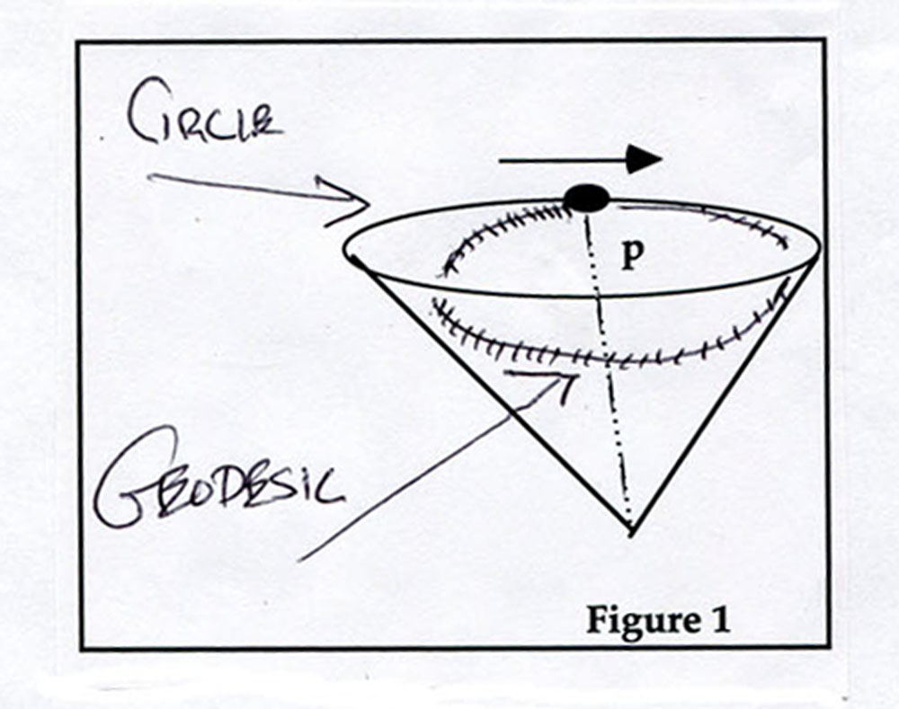
(4) The metric itself changes. That is to say, if one cannot detect one’s own motion, but one can detect a change in the metric, one might argue that this indicates the presence of either motion or a gravitational field. This appears to be the viewpoint of General Relativity.
Definition: An inertial frame is the collection of all real and potential observers {O_{α}} which, to an observer O subject to an inertial motion on a uniform surface M, appear to be at rest.
The existence of inertial frames was fundamental in the arguments advanced by Copernicus, Galileo, Newton, and others to argue that the earth was spinning around its axis and turning about the sun: the assumption that the Earth is stationary, obliges one to adopt a different law of gravitation for the sun, each planet, and the stars. If there is one set of universal dynamic law, to which the Earth is no exception, one must acknowledge a principle of universal relativity of inertial motion. The existence of reference frames identifies a host of secondary deviations from them through which one can infer the presence of accelerating forces.
Observe that General Relativity abolishes reference frames! For an excellent treatment of some of the problems involved, look at this article, available on the Internet: Does Quantum Mechanics Clash with the Equivalence Principle—and Does It Matter?:
Elias Okon & Craig Callender (2011). http://philpapers.org/rec/OKODQM
Principle 3: The relative motions of Inertial Frames form a group
What this means is the following: Let O₁ , O₂ , O₃ be 3 observers, each ( by definition) at rest in his own inertial frame.
(i) If O₁ is at rest relative to O₂ , then O₂ will be at rest
relative to O₁ . (Identity)
(ii) If O₁ sees O₂ as being subject to an inertial motion, then
O₂ sees O₁ as being subject to an equal and opposite inertial
motion. (Inverse)
(iii) If O₁ sees O₂ as moving in an inertial motion of velocity
v₁ and O₂ sees O₃ as moving in an inertial motion of velocity v₂,
then O₁ will see O₃ as moving in a inertial motion of velocity
v₃ = f(v₁,v₂ ), where f is a group addition, (simple addition, tangent addition, relativistic addition, etc. )

Two things are implied by these definitions. O₁ will observe
(i) that O₃ is moving along a geodesic ; and
(ii) The relative velocities between O₁ , O₂ and O₃ are given by f.
Definition: A Relativistic Manifold (Galilean, Special relativistic, etc.) is one on which it is possible to build a kinematic structure satisfying Principles 1,2, and 3, in either strong or relaxed forms. Informally speaking, an inertial motion is uniform motion along a geodesic. In a relativistic manifold the inertial motions form a group and one can speak of inertial frames and rest frames.
The ramifications of being able, and not being able to detect one’s own motion can become ratherserious , as one knows from the history of relations between Galileo and the Vatican. Feeling that one is at rest is apparently not enough; secondary evidences (Foucault Pendulum, Transit of Venus, etc.) can indicate that one’s own motion may be a better explanation.

Applications to some fundamental 2-Manifolds:
(A) Principles 1 and 2 are satisfied on a spherical surface.
However , although a sphere is a strongly uniform surface, the inertial motions do not form a group. Let X,Y be two observers, initially at rest, with X on the equator, Y between the equator and North Pole. If X starts to move along the equator at a uniform velocity u, he will observe Y to moving with a lower velocity along a circle which is not a great circle, thus not a geodesic.
(B) The cone surface satisfies the relaxed form of P₁ but not the strong form. It does not satisfy P₂ . It does satisfy P₃ : the geodesics are everywhere flat, and inertial motions form a Group, at least within small patches determined by the distance from the vertex.
(C) There are 3 distinct classes of geodesics on the cylinder . Despite this, as we shall show, the intrinsic geometry of the
cylindrical surface is a Galilean relativistic manifold. The same is true for the flat torus which, however, has loops of all orders and geodesics that are everywhere dense in the manifold.
On a Special Relativistic Manifold, inertial motions are further
limited by two conditions:
P₄ ( Light Principle ) :
(i) The speed of light , c , is an invariant constant in all
reference frames. One can argue that this implies that one cannot detect changes in the speed of light: see my paper “On Spontaneous Changes in the Speed of Light” http://www.fermentmagazine.org/lightspeed.pdf
(ii) c is also the maximum speed at which a signal can be
transmitted.

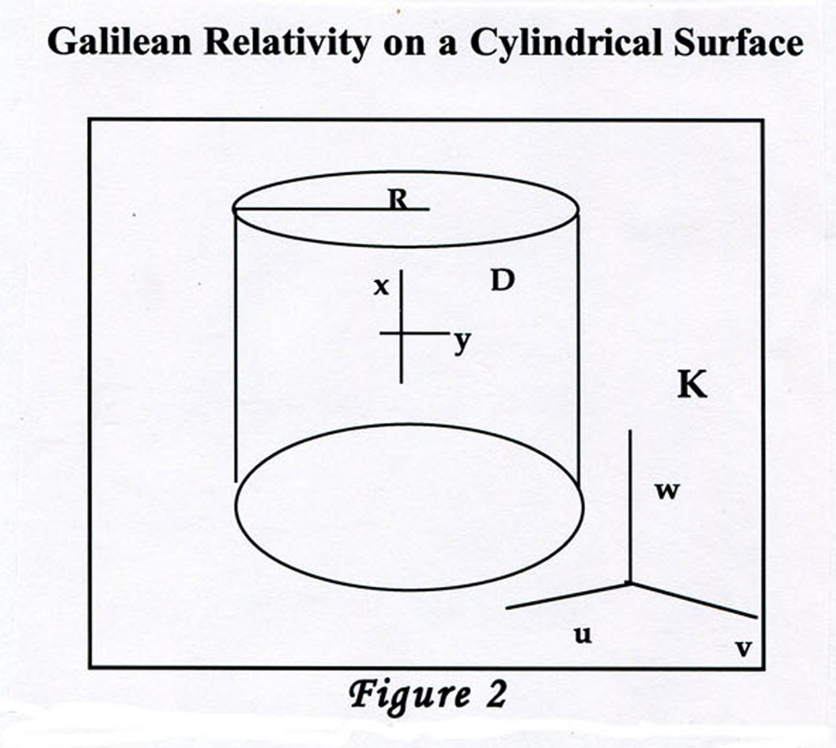
u² +v² = ρ² , ρ = constant
Intrinsic local geometry on K is Euclidean: K is a ruled surface with 0 Gaussian curvature. Choosing an arbitrary “origin” O on K, and taking as the ‘natural length” the circumference D = “1”, the intrinsic coordinates on the cylindrical surface are simply (x,y):
We will be studying Galilean Relativity in the space time (x,y,t). Initially we assume that the cylinder is embedded in an ordinary 3-space (u,v,w; see figure 2) where we, as observers can observe a particle p as being either “at rest”, or moving along a geodesic line at a fixed speed v relative to us. This is not an inertial path in 3-space, but one of 3 possible lines: a generator line, g; helix h, or loop l. We will show, however, that these are inertial frames on the cylinder K.We open K along a generator line including the point, p. and flatten it on the plane:
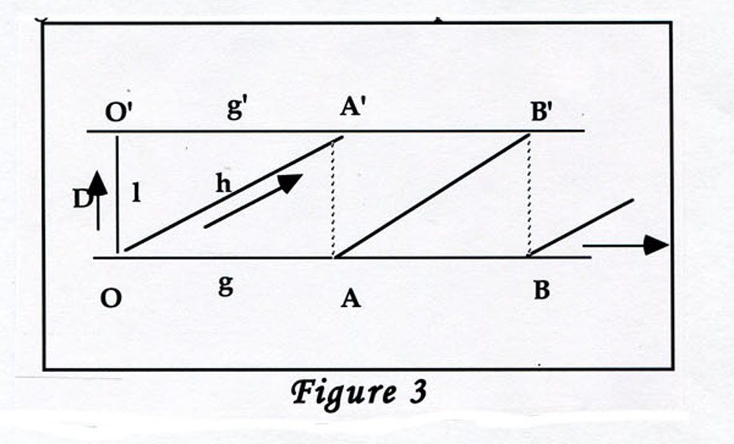
In figure 3 the “origin” O has become a pair of identifiable points O and O’, at unit distance apart in the vertical dimension. The line connecting them is a circular loop, l. All of these loops are parallel and of the same length, which is conventionally set to 1. It is completely flat in the intrinsic geometry.
Right away one sees the kind of problem that arises when trying to impose Einstein/Poincaré Special Relativity onto the cylinder: Consider twins J and H at O . Let H move away from J at velocity v. Then, just before reaching O’, suppose H decides to turn back to O. By the twins paradox, he will be younger than J when he returns. However, had he continued on a slight distance, the motion between J and H would have remained completely inertial from beginning to end and there would be no difference between their ages !
One cannot have Special Relativity in Cylindrical Flatland.
Galilean Relativity poses no such difficulties. Figure 3 shows the 3 kinds of geodesic (as seen from the ambient 3-space). The generator lines g are at right angles to the loops. The helices h cut the generators at a fixed angle , α . Either α or tanα can be called the “pitch” of h relative to g.
From the ambient space, the distinctions between l, g and h are absolute, but become completely relative when seen by an observer on K. Flattening the cylinder as in Figure 3, h turns into a striation
To better study the helices, we develop the cylinder over
the plane. The plane itself is fibrated by a series of congruent
horizontal strips, each representing a turn of the helix. These strips are identified with the initial strip, and the two lower generator lines identified with each other to reproduce the cylinder. (See Figure 4)
The helical line h "connects up" as an unbroken straight line formed by conguent segments h₁ , h₂ , h₃ .
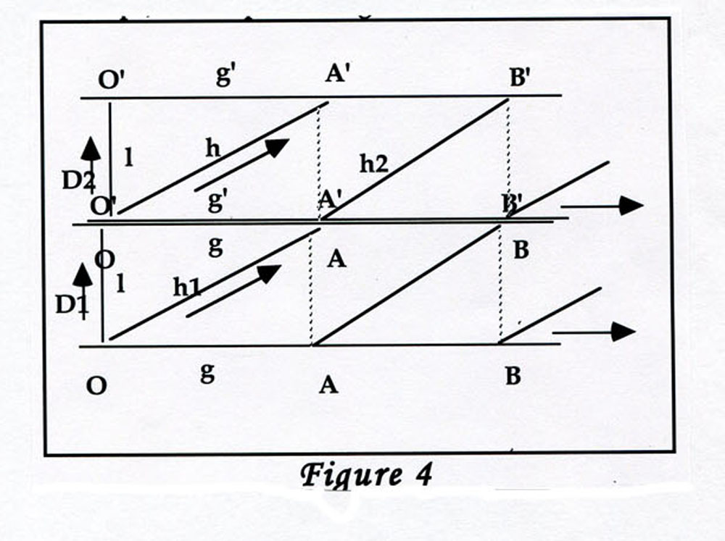
Basic Theorem
No reference frame in cylindrical Galilean space-time
has any distinguishing qualities. It is impossible by any experiment
to determine one's own velocity along any of the geodesics l, g or h . Furthermore, the distinction of loop, generator or helical geodesic is relative only. Given any geodesic s , and an inertial motion of velocity v (as seen from the embedding space), there exists inertial reference frames on K in which it will appear to be, respectively, a loop, generator or helix.
Proof : As embedded in 3-space, the points on the cylinder K , with radius ρ , have external coordinates (u,v,w) . (See Figure 2) The equations of the 3 kinds of geodesic are, respectively:
(1) Generators : u= c₁ , constant ; y = c₂ ,constant c₁² + c₂² = ρ²
(2) Loops : w = c₃, constant.
(3) Helices : u = ρwcosλ, v= ρwsinλ

On the flattened surface (Figure 3) the natural intrinsic coordinates are the generators and the loops, (g,l) , with the circumference D conventionally given as the natural unit of length, 1. The classes of geodesics are:

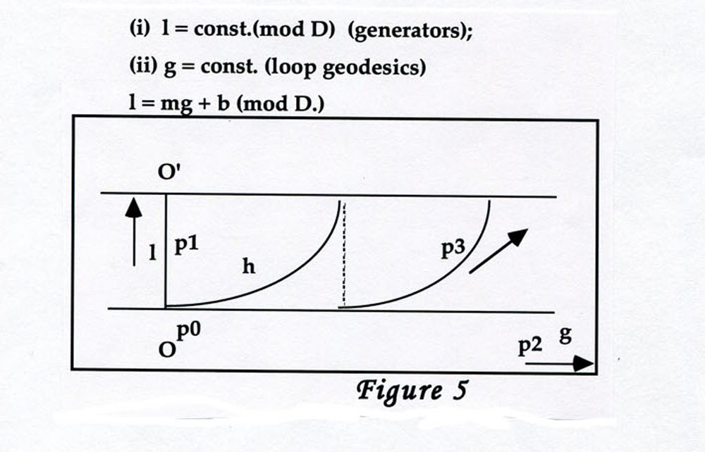
Assume that observer p₀ is 'at rest' relative to the reference frame of the embedding space (u, v, w). p₀ observes the 3 “spectators” p₁ , p₂ , p₃ moving along the 3 kinds of geodesic with velocities v₁ , v₂ , v₃ .
Question 1 : How do the spectators see the motion of p₀ ?
To p₂ , p₀ is moving in the opposite direction along a
generator, at velocity -v₂ . Likewise, to p₁ , p₀ is "rotating" along a loop at velocity –v₁ . To see how the motion of p₀ appears to p₃ , develop the cylinder on the plane:
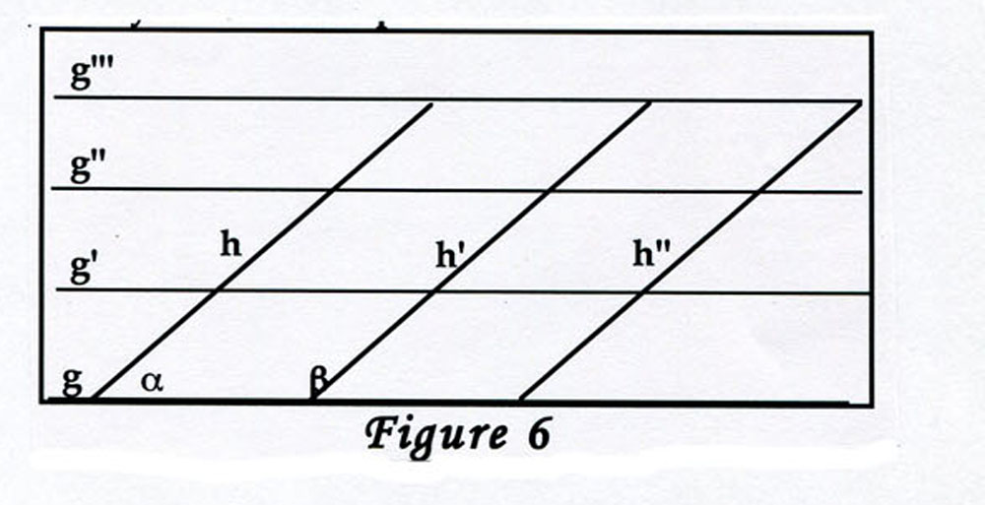
The lines g , g', g'', etc., cut the lines h,h',h'' at the same angle β = π−α Therefore, when p₀ sees p₃ moving along a helix with pitch tanα , p3 will see p0 moving away on a helix with pitch tanß
= tan(π−α ) = -tan α , therefore at velocity -v₃ .
Question 2: How does the motion of p₁ (along g) look to the observer at p₂ (along l) ? Clearly this will be a helix, the pitch of the helix being a function of the ratio of the velocities v₁ /v₂ . Suppose that p₂ moves a distance d= v₂t along the generator , t some fixed amount of time. p₁ will then move along the loop a distance v₁t (mod1).The successive recyclings of this loop translate into apparent twists of the path of p₂ around the cylinder. Hence -v₁/v₂ = tanα is the pitch with which this helix appears to cut the generator seen by p₀ . This generator is perpendicular to p₁ 's perception of the direction of its own loop.
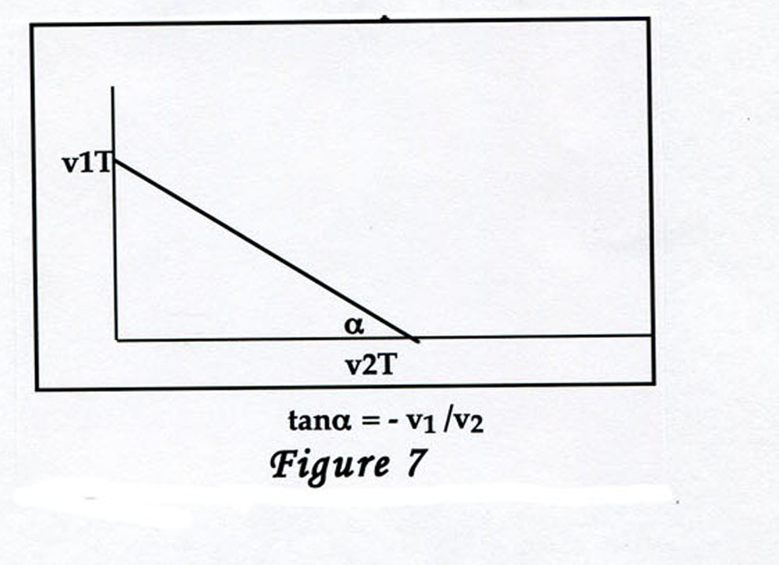
Likewise, p₂ will perceive p₁ moving along a helix with angle
β= π/2 −α ; tanβ = v₂ /v₁ . The relative velocity is given by the
length of the hypoteneuse of the above triangle, divided by the
time t.
Question 4: Finally one asks how a traveler along one helix h₁ will look to someone traveling along another helix h₂ .
Observers at every point on the cylinder are at the origin of a natural Cartesian frame, with abscissa given as the generator g, and ordinate the loop l. By developing the cylinder on the plane, one sees that two helices will either be parallel, or continue to intersect infinitely often. If those intersections are synchronized for spectators travelling at the same velocity they will appear to be loop geodesics. If the velocities are different they will appear to be helices. Geodesics go into geodesics.
Conclusions:
(1) The dynamical space on M is everywhere self congruent
(2) The inertial motions form a group
(3) Given two points, p₁, p₂ on the cylinder, at rest relative to the 3-dimensional exterior, one can impose an inertial motion on p₂ that will make p₁ appear to move on any one of the 3 geodesic forms, loop, generator or helix.

