Axioms and a Model
for a Double-Intersection Geometry

Roy Lisker
May 7,2007
rlisker@yahoo.com

Our discussion is situated throughout in a 2-manifold M. M is diffeomorphic to an open sub-domain of R2, connected but not simply connected, and without boundary. A generalized projective geometry, G, will be installed over M, with the property that for all but an exceptional class of line-pairs and point-pairs, two lines intersect in two points, and two points can be joined by two lines. G is therefore a self-dual geometry, a property that is enshrined in the following meta-axioms:
LANGUAGE META-AXIOM: The language of G will be that of projective geometry, including itsEuclidean, elliptic and hyperbolic variants.
DUALITY META-AXIOM : Every theorem and construction involving the concepts of line and point produces another theorem or construction when line and point are interchanged in their statement.
Let MC be the embedded image of M in R2 . The closure of MC will add the line at infinity L∞ and a point at the origin, called the vertex V. These can be formally adjoined to M via the technique of compactification. Sometimes we will be working in M, sometimes in

MC. When there is no confusion they will be referred to, indifferently, as M.
A. Construction Axioms
Axiom I: Lines in G and on M are curves without endpoints, with a single terminal endpoint in their closure, on the line at infinity.
Definition: Lines L1 and L2 are called parallel if their closures meet at the same point on the line at infinity
Axiom II: Generators in G and on M are curves without endpoints, with a terminal endpoint in their closure on the line at infinity, and the other terminal endpoint in their closure at the vertex.
Definition: Points p1 and p2 are called "seperal" if they fall on the same generator. Because of their endpoint properties, it is clear that lines cannot be generators, nor generators lines.
B, Intersection Axioms
Axiom III: Any two non-parallel lines intersect in two and only two distinct points
Axiom IV: Any two non-seperal points can be joined by two and only two lines.
Axiom V: A pair of seperals, p, and q can be joined by no line and only one generator.
Since seperal points cannot be joined by a line, it follows that generators can intersect lines in at most one point.
Axiom VI: For any point p, there is only one generator gp through p.
Axiom VII: Let L be a line and p a point not on L. Then one and only one parallel line can be drawn through p and parallel to L.
Axiom VIII: Let L be a line. Then there is one and only one generator g parallel to L, .i.e. that meets L at the line at infinity
Axiom IX: Let L be a line and p a point not on L, and gp the generator through p. If gp is not parallel to L, then there is one and only one point q on L seperal to p. If gp is parallel to L then the point at infinity where they both meet can be taken as the unique seperal, q, to p on L.
Since the line at infinity has been removed, the manifold M is topologically equivalent to the Euclidean Plane, E2 with a point removed at the origin. One can therefore apply the Jordan Curve Theorem to M and speak of the "interior”, IntD of any simple non-intersecting closed curve in M.
The fundamental rigid body in G is the "bi-angle", or "bangle" formed by two non-seperal points a and b, and the line segments A and B connecting them:
Theorem: A bangle is a simple, non-intersecting closed curve.
Proof: If segment X intersected Y at any point other than x and y, then 2 lines would intersect in 3 points, contrary to the axioms.
Theorem: (Jordan Curve): The interior IntB is well defined.
Definitions:
A region D with boundary C, where C is a simple non-intersecting closed curve, is said to be weakly convex, if for every pair of points a, b on, there is at least one line segment between a and b entirely in .
A region D with boundary C, where C is a simple non-intersecting closed curve, is said to be strongly convex, if for every pair of points a, b on, both line segment

between a and b lie entirely in .
Axiom X: All bangles are strongly convex
Theorem: The bangle interior IntB (p,q) of two points always includes the vertex.
Proof: Let gp be the generator through p. Let the component of gp passing through the interior of B (p,q) be designated hp. Now hp cannot exit B. Were it to do so it would intersect either P or Q, one of the two line segments defining B. This would make gp a line, not a generator.
Theorem: Let D be a weakly convex domain bounded by a simple closed curve, which does not include the vertex in its interior. Then D has the property that all lines and generators intersect in at most one point, that is to say it cannot be strongly convex anywhere. We will call this the "Euclidean property".
Clearly, if there were two points in D for which two lines could be drawn between there, D would include the vertex.
Corollary: Let p be a point other than the vertex. Since, in MC, V is just a point in R2 which has been removed, it is possible to draw a normal convex neighborhood Np around p which excludes V. This will have the Euclidean property.
Metatheorem: Any double-intersection geometry which includes Axiom X must have generators and seperals, that is to say, point pairs that are not connected by two lines.
Proof: Let B(p,q) be a bangle. Let Np be a locally Euclidean neighborhood around p. Choose a series of points converging to p,
such that:
By strong convexity, each bangle is contained in the previous one. One can therefore take the topological limit and write:
Take the closure of C1. This is still strongly convex. If it has a non-trivial interior, one may continue the process with a new set of points converging to p, and so forth. The series cannot converge to a single point, that is to say to p only, because all of the regions, bounded by lines with the double intersection property, must cross the boundary of the locally Euclidean neighborhood Np .Thus the descending chains of regions eventually arrive at a figure whose boundary is a single line segment S with no interior.
Since generators are drawn from the line at infinity to the vertex, the vertex of MC must lie inside the image of B in R2. Hence in the compactification of M, V lies inside B.
Since the vertex lies in the interior, one can construct a locally Euclidean neighborhood Np around p which will include V as a boundary point. Thus the generator segment S can be extended all the way to the vertex. As p is arbitrary, S can be extended in the other direction all the way to the line at infinity.
Theorem: Generators extend from the vertex V to the line at infinity L.

A Model for G
The basic features of double-intersection geometry have been abstracted from the geodesic geometry on the cone. The general equation for a right circular cone in Cartesian coordinates in 3-space is given by:
We will be looking at one particular example of this, namely

Conical Geometry provides many examples of simple yet interesting extensions of ordinary plane geometry. Since the Gaussian Curvature at each point is 0, the local geometry on the cone surface is everywhere indistinguishable from Euclidean geometry. We ourselves may well be living on a 4-dimensional cone’s surface and not know it until a light beam returns to us from an unusual direction. The geometry of a 3-D cone's surface can easily be visualized by unfolding the cone and laying it flat on the Euclidean plane.

Figure 1.
The geodesics become ordinary straight lines, while the generators translate into the pencil of lines emanating from the vertex. The conic sections have more complicated equations.
Let the central angle of the cone in 3-space be designated 2ψ , and the central angle of the unfolded cone α ; the reason for the coefficient 2 will become apparent in a moment. In Figure 2 the cone has been unfolded along the generator line g . Let pp' be a line drawn across the flattened sector, intersecting the two copies of the generator line at distances r1 and r2 . If r1 > r2 then it is clear that if the cone be refolded to its original configuration in 3-space, these two points will not coincide . Therefore the generator line gwill intersect the geodesic pp' in two places . Since generators are also geodesics, this already shows that every cone whose vertex angle in the corresponding flattened sector is less than π has points between which there are more than one geodesic .
We now compute the relationship between angles 2ψ and α :
Figure 2
From Figure 2 one sees that if B is the circumference of the upper circle , A the distance from the vertex, then B will be both the circumference of a circle of radius R in space, and also the length of a circular arc of length A in the plane when flattened out. Clearly:

From this one sees that, if k = 3, the “central angle" α will be π , and the two copies of the opened generator will lie on the same straight line.
Theorem: The intrinsic geometry on the surface of K, minus a generator g and the vertex V, is that of a Euclidean upper half plane with the abscissa xx' removed. In particular there are no self-intersecting lines.
Proof: Let l be a geodesic curve on the surface of K. Let h be the generator whose intersection with l cuts off the minimum distance from V to l. h will then be perpendicular to l, and it is clear that the generator g which forms an angle of π/2 with h will be parallel to L.

If the cone surface is opened along the generator g and laid flat on a plane, the line l will be parallel to the two branches of g. Since the line l is arbitrary, opening the cone along any generator will produce a Euclidean geometry on the upper half plane, provided that no line crosses the generator. In particular
(1) There are no self-intersecting lines, (as one finds for all values of k > 3)
(2) The sum of the angles of a triangle = π.
All relationships between lines and points are isometric with those of Euclidean geometry on the upper half plane.
If one returns the generator g to the opened cone surface, then identifies the lower half plane with the upper by rotating the upper half plane counter-clockwise on R2 , one constructs the double intersection geometry G.
L1 and L2' are segments of the same line. L2 is the transposition of L2' to the upper half plane by identification. L1 and L2 are segments of the same line in the double intersection geometry, G.

Note that the distance D of each branch of the line from the vertex is the same. Using this it is a simple matter to convince oneself, either by working with diagrams , or by algebraic solutions on sets of simultaneous linear equations, that all lines are either parallel or intersect in 2 and only 2 points.
Theorem: The angle around the vertex is π. Clear by construction
Theorem: If B(x,y, X,Y) is a bangle, then the sum of the angles at the two vertices is π. The diagram for a bangle with one vertex on the opening generator is this:
The distances yaV and Vay are equal: the two points y are identified. The angle at the y vertex is created by bringing together the two branches of the generator. Therefore the total angle at the vertices of the bangle is equal to the sum of the angles of the triangle on the diagram, and is therefore equal to π .
Theorem: Let T be a triangle on the cone surface which includes the vertex. Then the sum of the vertex angles of T is 2π .
Once again this theorem is easily seen to be true by virtue of a properly drawn diagram. We imagine ourselves to be looking down on the vertex of K as it is positioned in 3-space:
The sum of the angles in each of the 3 subtriangles is 3π. Since the angle at the vertex is π, one subtracts this to obtain 2π for the triangle ABC.
In general, if P is an n-gon with the vertex in its interior, the sum of its vertex angles = (n-1) π.
One can say, in general, that the criteria for any set in G to have "non-Euclidean" properties, is that points intersect every generator at least once. If even one generator g is not intersected, the cone can be unfolded by cutting along g to produce a Euclidean upper half plane.
There is a simple relationship between the lengths of the sides of a bangle B (p,q,P,Q), and the lengths of the radius vectors from the vertex to p and q
Theorem:
It is sufficient to note that the line b from x to V is the median, to the generator segment y’Vy. Let the angle between b and Vay be designated θ . Then the angle between b and y'aV will be π−θ . By the law of cosines:
The result follows.

Corollary: If X ≤ Y, then:

Circles
Using the vertex as center, draw a circle C on G around V. The following results can be easily computed:
(1) If the radius of C is r, then the circumference will be π r and the area 1/2 πr.
(2) Let r= 1. If the sector formed by an inscribed angle includes the vertex, then the value of the angle is one-half the subtended arc plus π/2.
Angle ABC = 1/2 (AC + π)

(3) If the inscribed angle does not include the vertex, then its value is twice the subtended arc

Angle ABC = 2AC

Tribangles

Given 3 points A,B,C, so that no two are seperals, connect them with non-intersecting lines a =BC, b,=AC c=AB, so that the interior of the triangle includes the vertex. The second lines u,y,w connecting BC , AC and AB respectively, form bangles B1(A,B, c,w) , B2(B,C,a,u), and B3 (A,C, b,y) .
Theorem: Each bangle lies entirely in the interior of ∆ABC.
Proof: Each bangle must include the vertex. Therefore the second lines must be inside for at least part of their trajectory. Thus, if c, in connecting points A and B were to go outside it would have to return, cutting off another bangle with one of the sides. But this bangle, being external to the triangle, would not include the vertex, although all bangles must include the vertex. Q.E.D.
Theorem: The union of the 3 bangles covers the whole interior of ∆ABC.
Proof: The lines u and y intersect inside ∆ABC at a point U. The union of the bangles B2 and B3 exclude the triangle ∆BUC, formed by sides a y and w. This triangle is locally Euclidean. Therefore the line u between B and C cannot go inside this triangle because in a locally Euclidean domain, only the line a can connect B and C. Therefore u must go entirely outside ∆BUC, and the union of the 3 bangles will cover the whole interior.
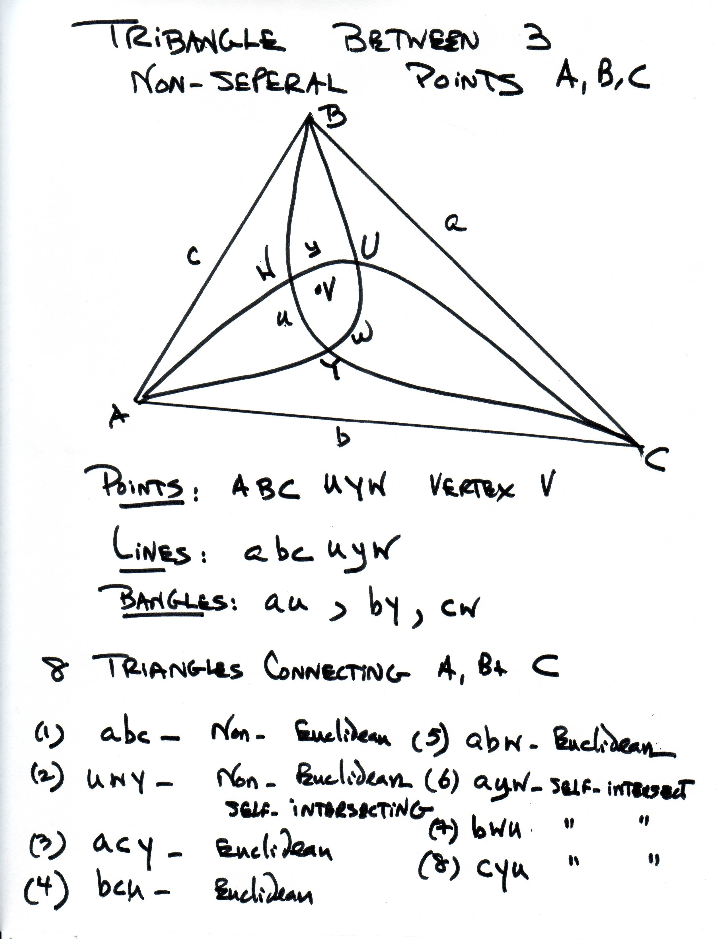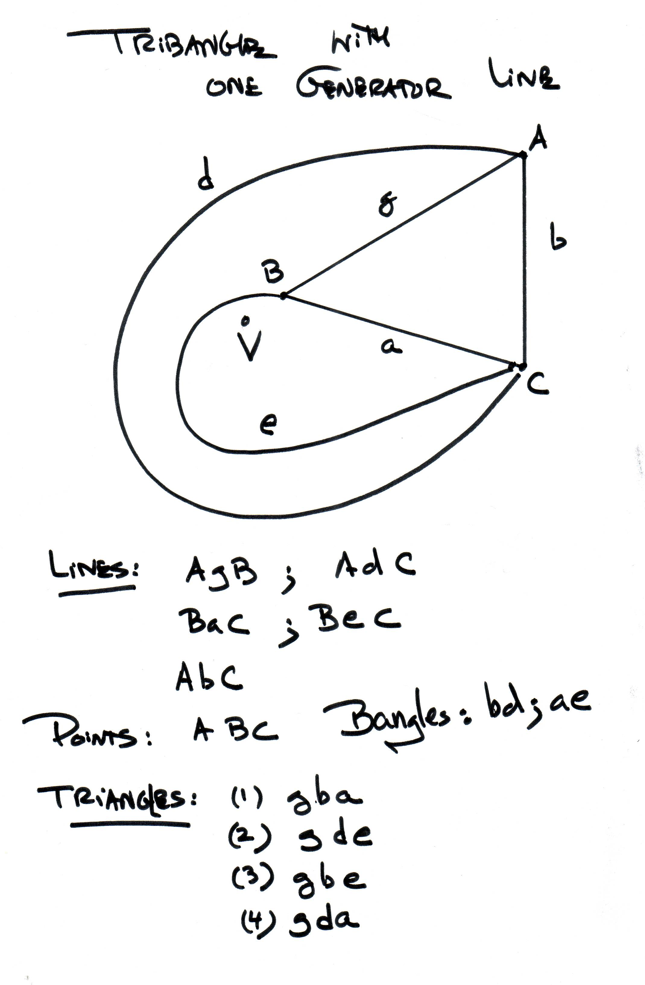

For the following discussion one may consult the two diagrams depicted above. Let A B C be the vertices of a triangle with sides u,v,w that include the vertex: V. Then there must be a second set of lines a,b,c, which also join, respectively, BC, AC, and AB. u and a must include the vertex, as must v and b , w and c. These must also intersect in 3 new points U,V, and W.
The complete figure A,B,C, U,V,W, a,b,c, u,v,w will be called a "tri-bi-angle". or tribangle.
Theorem: If no two of the points A,B, and C are seperal, then they can be connected by 8 triangles.
Proof: The 8 triangles are formed by the lines abc, abw, acy, bcu, awy, buw, cuy and uyw
I. 2 of these are strongly convex and include the vertex these are the ones formed by intersecting the lines a,b,c at A,B,C, and the lines u,v,w at U,V and W
II. 3 of them are Euclidean. These are formed by the lines (i) a, b, w, (ii) a, c, v and (iii) b, c, u all intersecting at A, B, and C
III. 3 of them are self intersecting at the points U, V and W and terminate in the points A, B, C.
Suppose now that two of the vertices, A and B, are seperals on the same generator, g. (The situation is depicted in the second diagram.) In this case the other connections between AC and BC will be lines d and e that do not intersect. This is because of Axiom X, which guarantees the strong convexity of a bangle. There will be only two bangles defined by the pairs bd and ae.
If all 3 vertices A, B and C are on the same generator, then neither triangles nor bangles are possible. However, if A,B and C are collinear, then, when making connections with the additional lines between AB, AC and BC, there will be one intersection point D of the bangles AB and BC. The third bangle AC will include the two others in its interior. A locally Euclidean triangle is formed with vertices A, C, and D.
Analytic Geometry on G
The most ‘natural’ coordinate system for G is that of polar coordinates from the vertex, with some generator g chosen at the abscissa from which to measure the angle q.
On the surface of the cone these are Euclidean coordinates, modulo π. However to get a better picture of what is happening it may be convenient to project the entire conic surface onto the Euclidean x,y plane, it being understood that when the angle at the vertex makes a full revolution of π, the angle at the origin the plane makes a revolution of 2π. Therefore, if one takes any polar equation describing a curve on the cone, and one replaces θ by 2θ, this will give the corresponding equation for the projection on the x, y plane. As all the intersection properties are invariant under this projection, one has a model for a double-intersection geometry in the plane.
In particular, a line on the cone with equation
becomes
.

Geodesics in General Relativity
One of the interesting areas in which to look for applications is in those situations in General Relativity when there are two geodesics between points a and b in space-time. If light, gravity and causation all move along geodesics, what does this tell us about cause and effect between a and b, normally treated as based on a unique connection. Also, since the paradoxes of Special Relativity depend upon the proper time between events in space-time, what happens when there are two candidates for proper time? These and other questions will be picked up in another paper.

PostScript, March 21, 2010
Elliptic and Hyperbolic Geometries
When the variants of these constructions in elliptic and hyperbolic spaces are made, distinction geometries result which are not difficult to describe.
Pictures will be supplied at some future date. Let H signify the upper hemisphere of a sphere in 3-space, E the equator. Locate a point on the equator, which can be arbitrarily designated as the “origin”, O. A line L will be defined as two great circle arcs in H which cut E at the same angle α to the left, at a distance d on each side of O. Since one is on the surface of a sphere, these must intersect at one point on H, (and one point in the “reverse complement” H’ of the lower hemisphere.)
Thus, the variant of our double intersection geometry in an elliptic space will have self-intersecting lines. Two “lines” L₁ and L₂ will intersect in 4 points. Thus, on the sphere, the double-intersection property translates into a 6-point complex formed by two self-intersection points and 4 cross-intersection points of two lines.
In a hyperbolic geometry G, one can have many parallels to a given line L passing through a given point P. The variant geometry in G will therefore have two kinds of line pairs L₁ , L₂ : those, which don’t intersect at all, and those which intersect in two points.
These options are easily displayed in figures, which will be
placed in this article at the author’s earliest convenience.

Dr. Roy Lisker
rlisker@yahoo.com
www.fermentmagazine.org

Some may argue that this should be spelt as 'separal', but it is obvious that the word 'separate' is mispelt in standard English.

