Hysteria and Enlightenment

Chapter 8

- THE MUSIC LESSON

Loved by the Muse was the bard; but she
Gave her of good and evil
Reft was the light of her eyes, but with
Sweetest song was she endowed
Homer
“There is a kind of virtue inherent in the world-soul
that is suffused throughout the universe”
-Goclenius

Towards evening of a day near the beginning of April, 1777, Marie-Therese von Paradis was again taken over to the Mesmer mansion. During her stay in his clinic, the Mesmers frequently invited her and her parents over for dinner. Afterwards Marie-Therese would play for them on the piano set up in the ante-chamber adjacent to the dining-room. Tonight, because of the devotion that Frau von Colnbach-Paradis always invested in dressing, grooming, and fixing up her coiffure, mother and daughter were half an hour late in arriving. No matter; the presence of special guests had delayed the dinner.
To her amazement and delight, Marie-Therese found two of
her music teachers already seated at the dinner table and waiting for her:
Carl Friberth and the Abbé Georg Joseph Vogler.
Singer, pianist and composer, Friberth had only recently left the employ of Joseph Haydn to take up a post as musical director for all Jesuit church activities in Vienna. His work as Haydn’s collaborator in the production anf performance of opera at the Esterháza palace in Eisenstadt had given him a solid reputation as a many-talented musician.
The Abbé Vogler has a more prominent position in music history. Only age 29 at the time of this reunion, he was court chaplain and second kapellmeister at Mannheim, the most important center for musical innovation in Germany at that time. A few years earlier he’d established his school of music. It soon became famous (some would say infamous) for its radical innovations in teaching, instrumental design and musical form. Mozart has some unkind things to say about him, which means nothing: it appears to have been considered unprofessional in that period for anyone to say (at least for public consumption) anything good about anyone else in one’s own field. In fact, Vogler would soon be heading home to await the arrival, in a few months, of Mozart and his mother.
Mesmer’s dinner invitation had been extended to him after the Abbé Vogler had approached Mesmer with the request that he be allowed to meet Marie-Therese von Paradis and observe her at the piano. The passionate commitment to music education which would figure prominently all through his career, had arosed his curiosity: what could he learn about the way artistic understanding follows the period of mechanical study of a musical piece, from watching the painful process by which Marie-Therese von Paradis was struggling to translate a new world of unfamiliar sensations into full understanding of her surroundings?
Later that evening, after seeing her parents and the other guests to the door, Mesmer had also arranged to take Marie-Therese over to the small private astronomical observatory he’d set up in an octagonal stone building on the grounds. The Astronomer Royal, the Jesuit priest Maximilian Hell, inventor of the magnetic therapies developed by Mesmer, had promised to drop by around 10 PM to confirm for himself the reports he’d been getting of the progress of Marie-Therese in the restoration of sight.

The dinner table was set off in an alcove next to a floor-to- ceiling French window. It was a charming place from which to look out onto the Viennese urban landscape. Spring had arrived early, the weather was warm; through the cautiously opened window circulated a slight breeze. Scarcely a cloud hovered above but the air was crisp; in a few hours once the sun had set, the temperature was expected to drop significantly.
Marie-Therese sat in a kind of rapture, absorbing her first encounter with the multi-colored pageant of twilight. Since going blind at age 3 she’d not experienced the series of changes that carry daylight into darkness, nor the many beautiful effects of weather, clouds and colors that play about the horizon. She’d been told what to expect; despite this, the spontaneous diminution of the natural daylight was frightening at first, much as a person may continue to experience fear of heights even when he knows that there is nothing to be afraid of.
But when the scarlet blush of the sunset spread itself over the basin of the Danube and beams of sunlight gleamed off the green patinaed cupolas of the Klosterneuberg monastery in the distance, her mood was transformed from acute anxiety to something akin to awe.
“ What an immense relief, Maman!” , she exclaimed, “ Nature has not totally abandoned us poor mortals after all. If I were doomed to endure the uninterrupted sunlight forever, I would surely go out of my mind. “
As the sun finally disappeared below the hills, she felt the tension and strain of the day’s hard labors, (due as much to her attempts to understand what she was seeing as the hypnotherapy itself), flow out of her system , giving way to a state of tenderness and comfort.
In the late 18th century people everywhere worked much harder than anyone does in the developed world today, and those who could afford to do so consumed what we would consider enormous meals. They were eaten rapidly, so that dinner of 15 dishes might be devoured in less than 45 minutes. Lacing every meal in the Austrian capital were many cups of thick black coffee. The Viennese had become addicted to coffee, heavy, syrupy and very black ever since the Ottoman Army had left behind their sacks of coffee after the failed siege of 1683.
The meal itself was something of a novelty. Carl Friberth had passed along to the Mesmers’ cook several recipes taken from the banquets at Esterháza palace. Following a hors d’oeuvres of sausages, patés and other snacks, the wine goblets were filled with sweet red Malaga wine and a big slab of boiled beef, heavily spiced, deposited on their plates. A ragout with dumplings was quickly devoured, followed by a brief pause.
Soon the silver serving plates, heaped with slices of pheasants imported from Bohemia were carried out from the kitchen. Following the instructions of Friberth, these had been garnished with salt, pepper and paprika, the fiery Hungarian spice that Haydn could never get enough of, then baked for over an hour. Not long afterwards, a new white wine made its appearance, the white frothy Bellingham Johannesberger.
Pastries, known as Mehlspeisen , croissants, tortes and other delicacies, appeared in cut glass bowls. These served as a kind of nasherei for occupying away the interlude before arrival of the desserts. While they waited, Franz Anton Mesmer asked Marie-Therese if she felt like playing something at the piano. She replied:
“I’ve developed problems coordinating my movements at the keyboard. These new visual signals seem to interfere with my muscular training. I’ve never had to worry about that in the past, but then my arms and hands were used to responding to sound and touch only. For the moment I’m able to keep my eyes closed while playing; let us hope that this will not grow into a serious handicap! It will be dreadful, doctor, will it not, if I have to sacrifice my career as a musician to my ability to see?
“But right now I am overjoyed at the chance of playing for my two teachers! ”
Everyone welcomed the suggestion, although Carl Friberth cautioned her to avoid virtuoso pieces until her cure was complete.
“Just a few pieces, professor Friberth, to get into shape. Then I hope you will recommend a piece from your days of working with Joseph Haydn.”
The Abbé Vogler encouraged her. “Go and play anything you wish, dear. This isn’t a formal concert. If you are like me, you just follow up on whatever catches your fancy! You can always learn from your mistakes. ”
Mesmer and Friberth stood up with her. Leading her by the hand, they walked her through the opened lace-curtained door to the piano in the adjoining antechamber. The piano was so placed that her audience could listen and watch from the dining-room. Friberth sat down beside her to the right .
Acting on a strong recommendation from Wolfgang Amadeus Mozart himself (a young man rarely known to praise anyone or anything beneath his own Olympian sphere) the Mesmers’ fortepiano had been purchased from the firm of Nanette Streicher. Daughter of piano maker Johann Andreas Stein of Augsburg, she’d recently opened her own shop in Vienna. It was very light, perhaps 1/10th the weight of a modern piano, shaped more like a harpsichord though already recognizable as the piano we are familiar with . The tone was beautiful and clear, but soft, rather pallid ,somewhat mechanical and with a relatively small carrying capacity. The sounding board was flat. There were only two thin strings (.012” in diameter) to each note, rather than the three one normally finds today. The feather-light hammerheads were covered with cloth or leather.
On the other hand the Viennese action was superb, better than that of the English piano, the rival that would eventually surpass it to become the standard instrument throughout Europe until the innovations of Erard in Paris, in the 1820’s, to meet the requirements of Chopin and Liszt.
Gripping the side of the piano for support, Marie-Therese felt her way around the bench. Once seated she experimented a bit with the keys, testing their size and shape, then roaming about the extent of the keyboard.
“Every instrument is slightly different .” she explained “ Five years have seen enormous changes in keyboard construction. Although I’ve played a few times on the Mesmers’ piano, it’s rather different from the one I use at home; it will take some getting used to. ”
For 10 minutes she played scraps of pieces and melodies, parts of fugues from the old masters and scale studies from contemporary manuals. Finally she announced that she was ready.
Just as she was preparing to play the gathering was interrupted by the sudden arrival of two new guests: Mariana de Martines and another Abbé , the eminent musician and historian Maximillian Stadler. The Mesmers had indicated that they might be coming, without being able to say when they could be expected.
Martines rushed into the dining alcove ahead of the butler:
”I hope we’re not late!”
Franz Mesmer smiled: “Musicians are always late for appointments.”
Friberth added, laughing: “Could that be because, my dear Anton, they have no sense of time?”
Stadler, coming up quickly behind Martines, and a more formal gait, nodded: ” Indeed! I make up all my tempi as I go along!”
“Come on; sit down!” Mesmer stood up and directed them to their chairs around the dinner table, “We can’t offer you much to eat, but dessert is on its way. ”
Although French fashions had (notably for women) been dominant in Europe for half a century, Mariana de Martines still adhered to many charming touches of the Spanish style of dress that had prevailed through the earlier period. There was an emphasis on black lace, her face partly veiled by an elaborately crocheted mantilla, an ivory fan and high shoes. The bodice was tight, the waist correspondingly slender, and she wore more jewelry than was then considered fashionable. At the same time she clearly had little patience for those hairdos that climbed more than half the height of their bearer, and which had, like the plague (and in compliance to the follies of the Emperor’s sister in Paris) been all the rage for the last 7 years. Instead, her hair was secured by a large broach of the sort that wasn’t being worn anymore, but served as an added adornment to the Spanish costume.
Rich, talented and well-connected – the daughter of the Papal nuncio to the Imperial court, no less! – she possessed at the same time a frank, benevolent nature that, in an age bristling with envy, disarmed the envious.
Only 33, Mariana de Martines was acknowledged everywhere as the most important woman composer in Vienna. The great librettist Metastasio lived with her family. Upon his death he would leave them his fortune. ( He must have been paid lavish sums for his libretti, as copyrights and royalties did not yet exist.) It was understood throughout all musical Vienna that the only reason Mariana de Martines had not be given a prominent post in the musical hierarchy was that she was a woman.

Neither blind nor financially dependent, with a solid reputation behind her as a composer of keyboard and church music, Mariana de Martines was blessed with a self-confidence that Marie-Therese, to whom Mariana was something of a role model, would never acquire. Warm-hearted and solicitous, she’d come that evening to watch the miracle of the restoration of Marie-Therese’s vision in that critical period in which mere seeing was turning into the understanding we call vision.
The Abbé Stadler was highly respected as a multi-talented musician, composer, historian and theorist. As a dinner companion he could be a bit tedious, even a bit of a bore, on account of his erudition. Certainly he was welcome, although the other guests could be excused for breathing a collective sigh of relief that there were not two of him present.
As soon as the new guests were seated and served, Marie-Therese von Paradis began to play. Inspired by the presence of so many celebrities of musical life, and despite the admonitions of her teacher, she could not resist the temptation to show off.
The first piece was a rapid Scarlatti piano sonata, in G major, tempo marking Presto, quanto sia possible. This was followed by another rapid baroque piece, the Prelude and Fugue of Padre Martini. Friberth applauded longer than the others. The Abbé Vogler commented:
“I studied with Padre Martini for awhile, but didn’t stay very long. I was much happier with Valloti. He made me into the odd bird of a musician I am today!”
Marie-Therese returned to the piano and played the rapid, difficult D-major Prelude from the first book of the Well-Tempered Clavier of
J. S. Bach, followed by the Fugue. Friberth turned to address her audience:
“Little Marie likes to show off. She wants to make sure that you all know that she can play! But she’s also an extraordinary musician.” He opened up a briefcase standing beside him on a chair and pulled out a handwritten manuscript:
“This is my own arrangement of a movement for string quartet by Joseph Haydn. Marie, could you give us your analysis of the Adagio in E-major ?”
Frau Mesmer interjected: “Before you continue, Marie-Therese, the servants have told me that the dessert is ready. We should eat it before it melts. I suggest we all return to the table and finish the meal. Then we can come back here.”
The new dishes were quickly distributed to all the guests. Baskets of several new Mehlspeisen were put at the center of the table. Then came the oranges and other fruits, and a wooden tray holding Parmesan cheese and a knife. Glass containers shaped like inverted bluebells were placed in front of each of the guests, holding chocolate, vanilla and pineapple sherbets. Marie-Therese was about to play some more and abstained from alcohol, but the other guests regaled themselves liberally from a tun of Tokay freshly arrived from Hungary.
The dessert finished, they followed Marie-Therese with their chairs into the next room. Marie-Therese seated herself once more at the piano, with Friberth seated to her right and Vogler standing and leaning over the keyboard at her left. Placing her hands on the keyboard, Marie-Therese played a single chord:
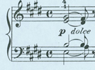
and stopped.
“ Feel the power of that opening E-major chord in root position. So bright, so confident! You can just imagine the summer heat soaking into your face and arms and shoulders. You want to bathe in it forever, you never want it to go away. That’s why Haydn wrote Adagio : It is very slow, rich, and full of the sun’s heat.” She replayed the first chord, then went on to complete the first phrase:
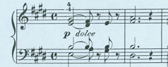
Franz Anton Mesmer hazarded a question: “ My dear, I don’t wish to appear presumptuous in the presence of so many professionals, but I’ve been led to believe that musicians don’t approve of using pictorial images such as “sunlight” or “summer” or “arms and shoulders” when it comes to music. Isn’t it correct to say that you understand music entirely through abstract relationships of form and pattern?”
All of them broke into spontaneous laughter:
“Not at all”, Marie-Therese chided, “We think in images all the time. Heaven help us that we should do otherwise!”
Thus encouraged, the Abbé Stadler commented: “This is a problem that has intrigued me for a long time. Purely abstract music is itself an abstraction, like ‘absolute beauty’ a kind of Platonic idea that doesn’t exist in the visible or audible world; while real music is made with real instruments propagating physical sound waves through real air.
“When I play a chord I hear something , that is to say, a sound combined with all the affective sensations, memories and associations that it conjure up. Nor could music, as an art, exist if it were otherwise.
“ Indeed, in the Baroque period, and to so extent even today, every key was assumed to have its specific affect or sympathy: C was joyous , E was associated with melancholy, G minor was only used for grim, even morbid music! Our ‘enlightened’ age (A cynical, though perhaps not entirely unsympathetic, chuckle went around the room) is more scientific. It considers excessive dramatisation in the baroque manner in bad taste, a kind of self-indulgence. We’re supposed to value ideas over emotions.
“That’s what got me into experimental music. I wanted to get as far away from personal involvement as possible, emphasizing the conceptual. I should tell you that, just recently, I’ve begun to experiment with writing music by tossing dice!”
“Tossing dice??” Joseph von Paradis’ bureaucrat’s cough was followed by a perplexed sigh. Mariana de Martines laughed outright, while Franz Mesmer’s face dropped with dismay:
“My word, Johann !” he cried, “What about the music of the spheres? Are they ruled by chance? As a religious man, you should know that God doesn’t play dice with the universe!”
The Abbé Vogler smiled mischievously: “Oh-ho! Watch it, Franz! That’s what got Galileo in trouble with the Pope!”
All of the 4 invited artists were connected with the ecclesiastical establishment and could therefore afford, without fear of reprisal, to be as mordanly anti-clerical as their imaginatins allowed:
“You mean, of course”, the Abbé Stadler replied, “ that ill-conceived phrase at the end of his Dialogue pro and con Copernicus, in which a simpleton expresses the view that God can violate all scientific laws whenever He chooses.”
“Yes”, Friberth mused, “but isn’t that what the Pope told Galileo instructed him to do? Disobedience, reverend, disobedience!” , his words terminating in a facetious grin.
“My good man, you don’t understand at all!” Vogler chimed up, “The Pope was only instructing Galileo as to what God had instructed him to say the night before!”
“Dice?” de Martines quipped, “I don’t think the good Lord likes to play dice! Cheating at cards, perhaps – because he knows he can get away with it!”
Stadler was amused: the great hypnotist could not acknowledge the usefulness of accident : ”It’s not so far-fetched as you might think, Franz. Artists waste too much time, you know, waiting around for – ahem- ‘inspiration’. Why not employ some technique or device to give inspiration a boost? At other times I use a pack of cards, or open pages at random in a dictionary. I must say I’ve grown rather fond of these chance operations.”
Friberth demurred: “My former employer, Joseph Haydn always has so many ideas going around in his head, he doesn’t need to wait for inspiration! By the way, and this is off the record - he’s written a Surprise Symphony! But it’s a deliberate joke.”
Stadler thought about this: “Well…I don’t compare myself to Haydn. I’m basically a historian. My head is much stronger than my heart. My intuition goes nowhere so I prefer experimentation. Sometimes I travel out to the countryside and transcribe the melodies of birds.”
The Abbé Vogler laughed: “Why do that, when you can come to me? Just like my name! Vogel!” Everyone had become caught up in the general merriment. Vogler went on:
“I’m known as the most notorious tone-painter in all Vienna! The point is that one doesn’t string these images together as a story. That’s being literal: literature and music are not the same artistic medium . The visual or verbal images that arise in the mind of a musician are no more logical than dreams, but they can be helpful when it comes to interpretation. Let me think of an example … a bright chord is, well, played with more brilliance!”
“So ,Marie-Therese, ” Mesmer, who had been struck by the similarity to the phenomena of hypnosis, asked “what is a gentle chord?”
She placed her fingers on the keyboard and played a softer, more delicate version of the opening chord of the Haydn. Mesmer’s face lit up with admiration:
“I see! ”
Friberth beamed. His student was acquitting herself well tonight . She went on:
“That’s why this new instrument is called a pianoforte or fortepiano-one hears both terms nowadays. What I’ve just done would have been impossible on the harpsichord.” Friberth nodded affirmatively, but commented:
“Agreed. But, Marie, remember what I told you: Haydn writes piano dolce in the dynamics. Can you account for that?” Marie-Therese smiled:
“ Yes. One can play it either way; soft, as opposed to loud, is compatible with both brightness and gentleness. This is the paradox isn’t it? The effect I caused was due to something called the ‘attack’, the initial gesture or body motion. It should be like sunlight itself: full of brilliance and heat, yet infinitely refined and gentle and quiet.”
Mariana de Martines nodded affirmatively. She knew quite a lot about the revolution that was taking place in keyboard instruments. In his famous account of his musical travels through Europe, Dr. Burney calls her, somewhat fatuously, the “St Caecilia of the harpsichord”. She added:
“ It’s commonly believed that one is unable to produce such effects on the harpsichord; but any accomplished harpsichordist knows that this isn’t entirely true. Contrasts can be obtained, but not so easily or dramatically. Just wait: Cristofiori’s brilliant innovations on the hammer mechanism are only the beginning!
“Marie-Therese? Do you remember anything from the premiere performance of my G-major harpsichord concerto which I gave a few years ago? There are many passages in it which demand effects of light and shade that few keyboardists can create, even on the piano. It’s all in the attack, as Marie-Therese suggests.
“The real problem with the harpsichord is that there’s no way to sustain the note. The right name for the piano should have been the sustenuto! “
Rather than responding directly, Marie-Therese turned to the keyboard again and played through the first 20 bars of the piano solo from the de Martines concerto from memory! She’d heard it only once, 2 years ago.
“Bravo, Marie! Bravo!” Martines cried, as loud, vigorous applause came from everywhere. Franz Mesmer leaned back in his chair, a finger to his lips:
“I dare say”, he mumbled, largely to himself, “Memory is every bit as fascinating as imagination. Could animal magnetism be used to bring back memories?” His large, speculative eyes swam in his face and his brow contracted as if suffering from a sudden, if brief, headache:
“ What a thought…”
Marie-Therese resumed her analysis of the Haydn Adagio:
“ This opening motif is like the announcement of a summer sunrise. It gains momentum up to the majestic explosion of bar 8, then fades very subtly and mysteriously , almost as an afterthought , into the nightfall ; just like that twilight we’ve all seen that continues to fill me with wonder and amazement.
“After seeming to return to the key of E, the descent to the key of B, is quaint and precipitous, achieved by a little step-ladder motif that carries one into the pre-dawn of the opening. the return to E major is- notice! - accomplished via a single note, a lone A , moving almost apologetically to G# :
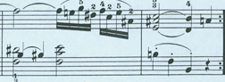
Stadler asked: “Couldn’t one also interpret that as an ordinary cadence on the dominant rather than a full scale modulation?”
Vogler laughed: ”That’s the joy of music. One effect has a thousand interpretations!”
Friberth explained: “It’s all a matter of context, as is everything in music. The little details leading up to the cadence on B give one the sense that all the furniture , in some sense, has been moved from the ‘house of E’ to the ‘house of B’!” He examined the score once more . Then he stood up to confer with the Abbe Vogler. After some discussion he returned to Marie-Therese and the others:
“ Did you notice? From the first bar he’s already modulating , in a manner of speaking, from the tonal orbit of E major into that of B major. After the second bar in fact, one is somewhat at a loss to state whether the piece is really in E or in B!” He indicated to Marie-Therese that he wanted to demonstrate something at the piano. She moved aside as he rolled up his sleeves and sat down at the keyboard:
“Listen to the sound of the B, the note just below middle C. It persists through all the changes in the first two bars, like a pedal point. One can almost imagine a tinkling bell, coming from some distant place, in the early dawn.” He played:
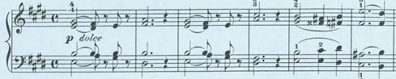
“ Directly or indirectly, the B persists all through the first half of the exposition. Yet we don’t actually arrive at the key of B until the very last bar in this passage, bar 11. It’s as if, from the beginning, we’ve set out on a road to a foreign destination. The sound of middle B is registering in our minds without our being aware of it. We only realized that we’ve arrived after the new room has been entered, the door closed behind us and the key turned in the lock.”
“Perhaps music is the language of the Unconscious…” Stadler mused, writing something down.
Dr. Mesmer hazarded a suggestion: “Would you say, then, Marie, that it’s as if the listener were experiencing the flux and reflux of the magnetic fluid, with a blockage in the middle that is eventually dissolved, leading to a mood of tranquil resolution?”
“O yes, certainly, doctor”, Marie-Therese giggled, “ the music is thick with obscurity! From the opening two bars, Haydn introduces a number of perplexing harmonic events that aren’t ‘explained’ in some sense until the middle E-minor section that’s coming up.
“Yet that is the genius of Haydn. That’s why, although the public for music has its favorites , we musicians recognize Haydn for what he is, Austria’s greatest living composer, perhaps the greatest in the world. He invented virtually every formal idea employed by modern composers, including your friend, Mozart. This Adagio is written in Haydn’s slow movement format, the very traditional A-B-A form, treated in a unique fashion.
“ In the first section, the A-section, one can generally expect some daring harmonic clashes. One considers them confusing at first; yet, once the entire piece has been played one realizes their functional significance. Indeed, it has been argued that, in some of Haydn’s compositions , one doesn’t fully understand the logic behind his harmonies until all four movements have been played! In this Adagio the language is simplified in the middle section in such a way that the role of certain ideas in the introduction become evident to the ear.”
“Just to trained musicians, of course. ” Joseph von Paradis suggested:
“Oh no, father, to everybody! The trained musicians can give you explanations of all the things he’s doing, with their names. But anyone who is able to appreciate good music feels the resolution of the ‘problems’ posed by each new idea as the piece progresses. It’s been called the style galant.”
“The expression is due to Quantz, I believe, around 1752. ” the learned Stadler informed them. She went on:
“Following the middle section - in a slow movement this is just an interlude, while in the rapid Sonata Allegro it can be an extended improvisation on several themes stated in the Exposition - the recapitulation of the A-section is embellished by ornaments and figurations. As we hear it once again we think, ‘So- that’s what that was all about!’ And we feel the sensations of having lived through a true adventure, full of charm and meaning. ”
The Abbé Vogler explained: “ You won’t find this way of thinking about music in the Baroque era. In a baroque composition the A-section returns as an exact repetition of the exposition at the beginning. There’s no clarification, no real development in the sense that we understand it today. This is indeed the style galant , or style elegant – excuse me, my French is lousy - and Herr Haydn deserves the credit for it. He combined a number of ideas from everywhere to create a universal style.
“For a long time, much of the music that was being written was all chaos and confusion. My word, you should listen sometime to the odd concoctions dreamt up by Willy Friedemann, J.S. Bach’s son in Berlin!”
“ Well, daughter”, Joseph von Paradis said, rather stiffly and slightly embarassed, “ I’m afraid I can’t understand most of what you’re telling us; perhaps it would help if my daughter could give us an illustration.”
“ Of course! It’s in the passage from bars 5 to 9. The effect is very clever, exciting, and most obscure ! I think, Doctor, that you are about to hear the blockage of the magnetic fluid!” She played:
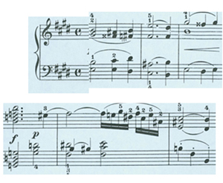
She stopped and turned to face her audience, convinced that they must all be as astonished as they ought to be:
“Ladies and gentlemen, I ask you: what is that G dominant seventh chord at the beginning of bar 8 doing, in an exposition which moves like a sunrise from E to B?”
A rhetorical question if there ever was one. Waiting for an answer and not getting one, she struck the chord again:
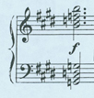
“ Eh! What’s that thing doing there? The G7 is the ‘signature’ of the key of C-major. It indicates C as infallibly as the sound of a voice indicates the arrival of a friend. Yet apart from that one chord, there is not a trace of C-major in this entire exposition! It’s all E and B, with perhaps some traces of F# thrown in. But one expects that, because the ‘submediant’, on F#, is often used as a bridge from tonic to dominant.
“ Of course, one can argue that F# is the major of F#-minor, which is the relative minor of A major, which is the major of A-minor, which is the relative minor of C major. But all that’s terribly far- fetched!” And she laughed and played a series of chords at random.
His interest considerably aroused , Friberth once again consulted and studied the score he was holding. A broad smile covered his face:
“ Before Haydn introduces that G7 chord, we are, ‘more or less’, in E. Right after that chord, by a very clever enharmonic re-writing of the f-natural as e-sharp” – a look of astonishment and a pause – “ we move chromatically to F#7, that is, the dominant seventh of B! It’s enchanting, and quite as mysterious as sunlight. But why? Throughout this piece, one feels light being covered over by darkness, then re-emerging again into light, though quite a different kind of light, or like the tides, or like Dr. Mesmer’s fluid, or like breathing itself. These transformations almost seem to happen note-by-note in some cases.”
Friberth asked her to replay the complete exposition:

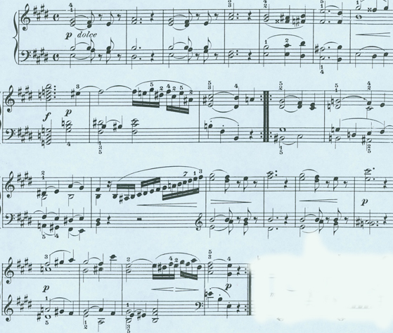
When she had finished, he went on:
“As young Marie-Therese has told us, we don’t really understand what Papa Haydn is doing until about 4 bars into the middle section. This is where we find, in some sense, the ‘explanation’ for the unusual harmonic activity in the exposition. The harmonic progression from bars 26 to 29 is virtually identical to what one hears between bars 7 and 10. Yet here, the “great ‘event” of the abrupt introduction of the dominant seventh on G in bar 9 becomes transformed, as if by magic, into a pair of sonorities. First there is an ordinary G7, what one calls a ‘secondary dominant’, moving in a standard fashion to a C-major triad.
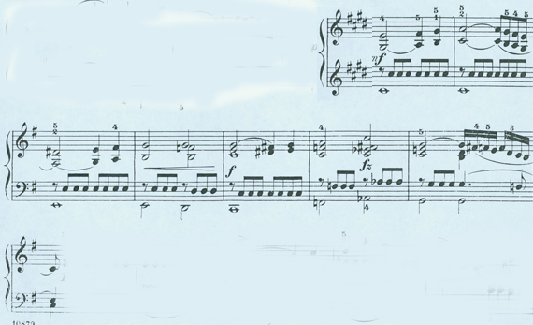
“Next: although the G7 chord is repeated here, the repetition of the event associated with this sonority in the A-section, is delayed, then re-occurs two bars later , in bar 28, where it turns out to be a tinkering with the subdominant chord sanctioned by tradition and known as a ‘French Sixth :

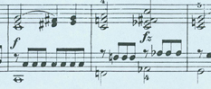
“Why the deuce do they call it a French Sixth?” Mesmer asked. The Abbe Vogler nodded his head:
“ It’s a silly terminology, Franz . In some respects what we’re dealing with here is a German Sixth resolved in an unusual way. The use of these harmonic sixth chords goes back to the Renaissance, but they’ve become the hallmark of the modern style. “
Mariana commented dryly: “The French think they’ve invented everything; unless of course it’s something one ought to be ashamed of, or nasty like a disease. Then they attribute it to the English.”
Stadler confirmed Vogler’s analysis: “ You see, adding the sixth degree to, say, a G-major chord, G-B-D, that would be E, produces a chord of the sixth. If the E is ‘augmented to E#, which is the same as F, the chord can also be interpreted as a dominant seventh on G! So right away you’ve got a kind of musical joke that can be used to modulate between keys, just like a pun on a single word can get one off onto a totally different subject!”
Marie-Therese laughed recklessly: “Yes. Like my name: “Paradis”! It can remind someone of “paradise” , yet to someone else it might suggest a collection of “parodies”, that is to say, imitations. Just like Vienna: the imitation paradise!” And she banged gleefully on the keyboard, modulating into regions of tonality that would not be heard in compositions until turn-of-the-century Beethoven! Everyone burst out laughing; the salon was in an uproar.
When the noise had died down, Vogler resumed:
“The musical pun is compounded by somehow turning the chord totally upside down, so that this F I’ve mentioned now becomes the root, that is to say, the sub-dominant of C, and one can actually move from this chord to the next one in such a way that F, rather than G, is the implied root. They sometimes call this a chord with two roots.When you do, you’ve got the French Sixth. When the chord resolves to the dominant, ( if the G7 had resolved right to B without going through F#7, you’ve got the German Sixth! It’s perfectly clear, isn’t it?” And he emitted a hearty laugh.
Frau Mesmer sighed: “You could repeat that explanation to me a hundred time, Father, and I wouldn’t understand a word of it!”
De Martines concurred: “It isn’t necessary to understand anything of what Maximillian has said. All that counts when you listen to the music is the final result, which should be , if done properly, perceived only as a novel way of modulating out of one key and into another.”
Friberth added: “Believe me, Frau Mesmer, Marie-Therese has gone to the heart of the matter: when the strange G7 chord appears for the first time in bar 8, even professional music theorists might quarrel over its functional purpose. But when the perfectly normal G7, followed by the French Sixth a few bars later, appears in the bridge, or middle section, even an amateur understands what’s going on.”
Marie Therese repeated the passage she’d just played, then remarked:
“ Technically speaking, the musically trained listener now knows that the odd chord he first heard in bar 8 was supposed to be understood as an augmented sixth chord on G. Then, when the exposition is repeated” - though still virtually blind she counted rapidly on her fingers - “in bars 44 to 45, we’ve been told how to interpret the novelty, and hear it with much satisfaction.
“ Notice how Haydn arpeggiates the chord to make it more grand and dramatic:
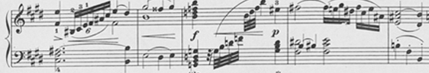
Marie-Therese apologized. She confessed that she could continue one for another two hours analysing this one Haydn piece of a mere 64 bars. She could not refrain from making one more observation before performing the Adagio in its entirety :
“At the very end of the return of the first, just before a brief coda, Haydn pulls off a dramatic tour-de-force. While the left hand rests on an E chord in 6-4 position, the right hand excutes a simple descending E major scale.”
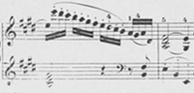
“Each of the notes is written as a staccato detached from all the others. By this time, every one of these pitches has been invested with some special function, some purpose or interpretation supplied by the unfolding of the composition. As the scale descends, one is invited to re-experience the delicate and delicious banquet of ideas which is now recollected in the way each note changes into the one following it .
“The upper E is the “tonic”. The motion to D# was the first harmonic idea of the work; the C# has frequently been the highest note in a phrase or sequence of phrases; it has acquired a special piquancy. The B, of course, has been the pedal-tone from beginning to end….. and so forth and so on . What a stroke of genius of this Herr Haydn, as if he were bringing out all the actors, one-by-one, to receive their deserved applause! “
Having said this, without more ado, she sat down again at the Streicher fortepiano and played the entire transcription from beginning to end:

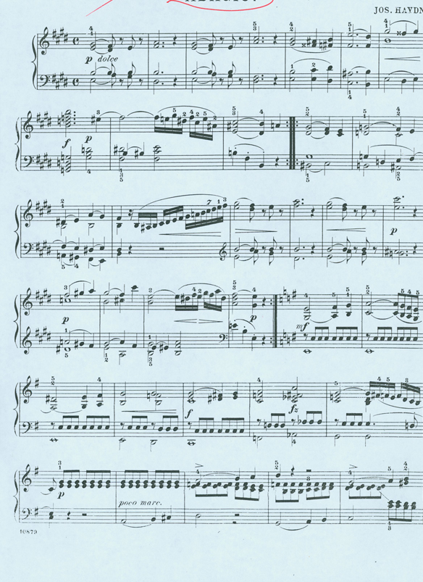
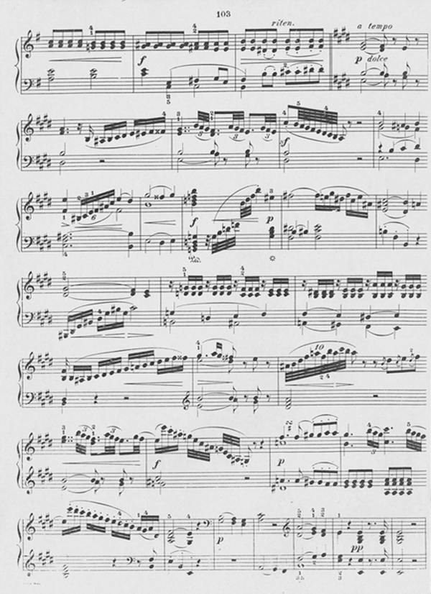

It was in Mannheim (perhaps due to the Abbé’s instigation?) that Mozart would contract the deadly “Weber” virus!
As an aside: this ‘failing’ did not appear to inhibit the careers of self-infatuated castrati , men damaged in childhood to give them woman’s voices. Until well into the 19th century, and even into the 20th, they continued to strut on the opera stage and warble in the choirs of the Vatican . Injustice, however ludicrous, is someone one can often comment on, but rarely do much about.
From what I’ve been able to learn, this appears to have been the first recorded use of this phrase in history!

